

DC-900 | DUST COLLECTOR
 | 10001051M ~230V, 50Hz

PARTS LIST

Walter Meier (TOOL) AG

Tämperlistrasse 5
CH-8117 Fällanden
Switzerland
Phone +41 44 806 47 48
Fax +41 44 806 47 58
jetinfo.eu@waltermeier.com
www.jettools.com

P-10001051M 2012-06

Parts Breakdown for DC-900 Dust Collector

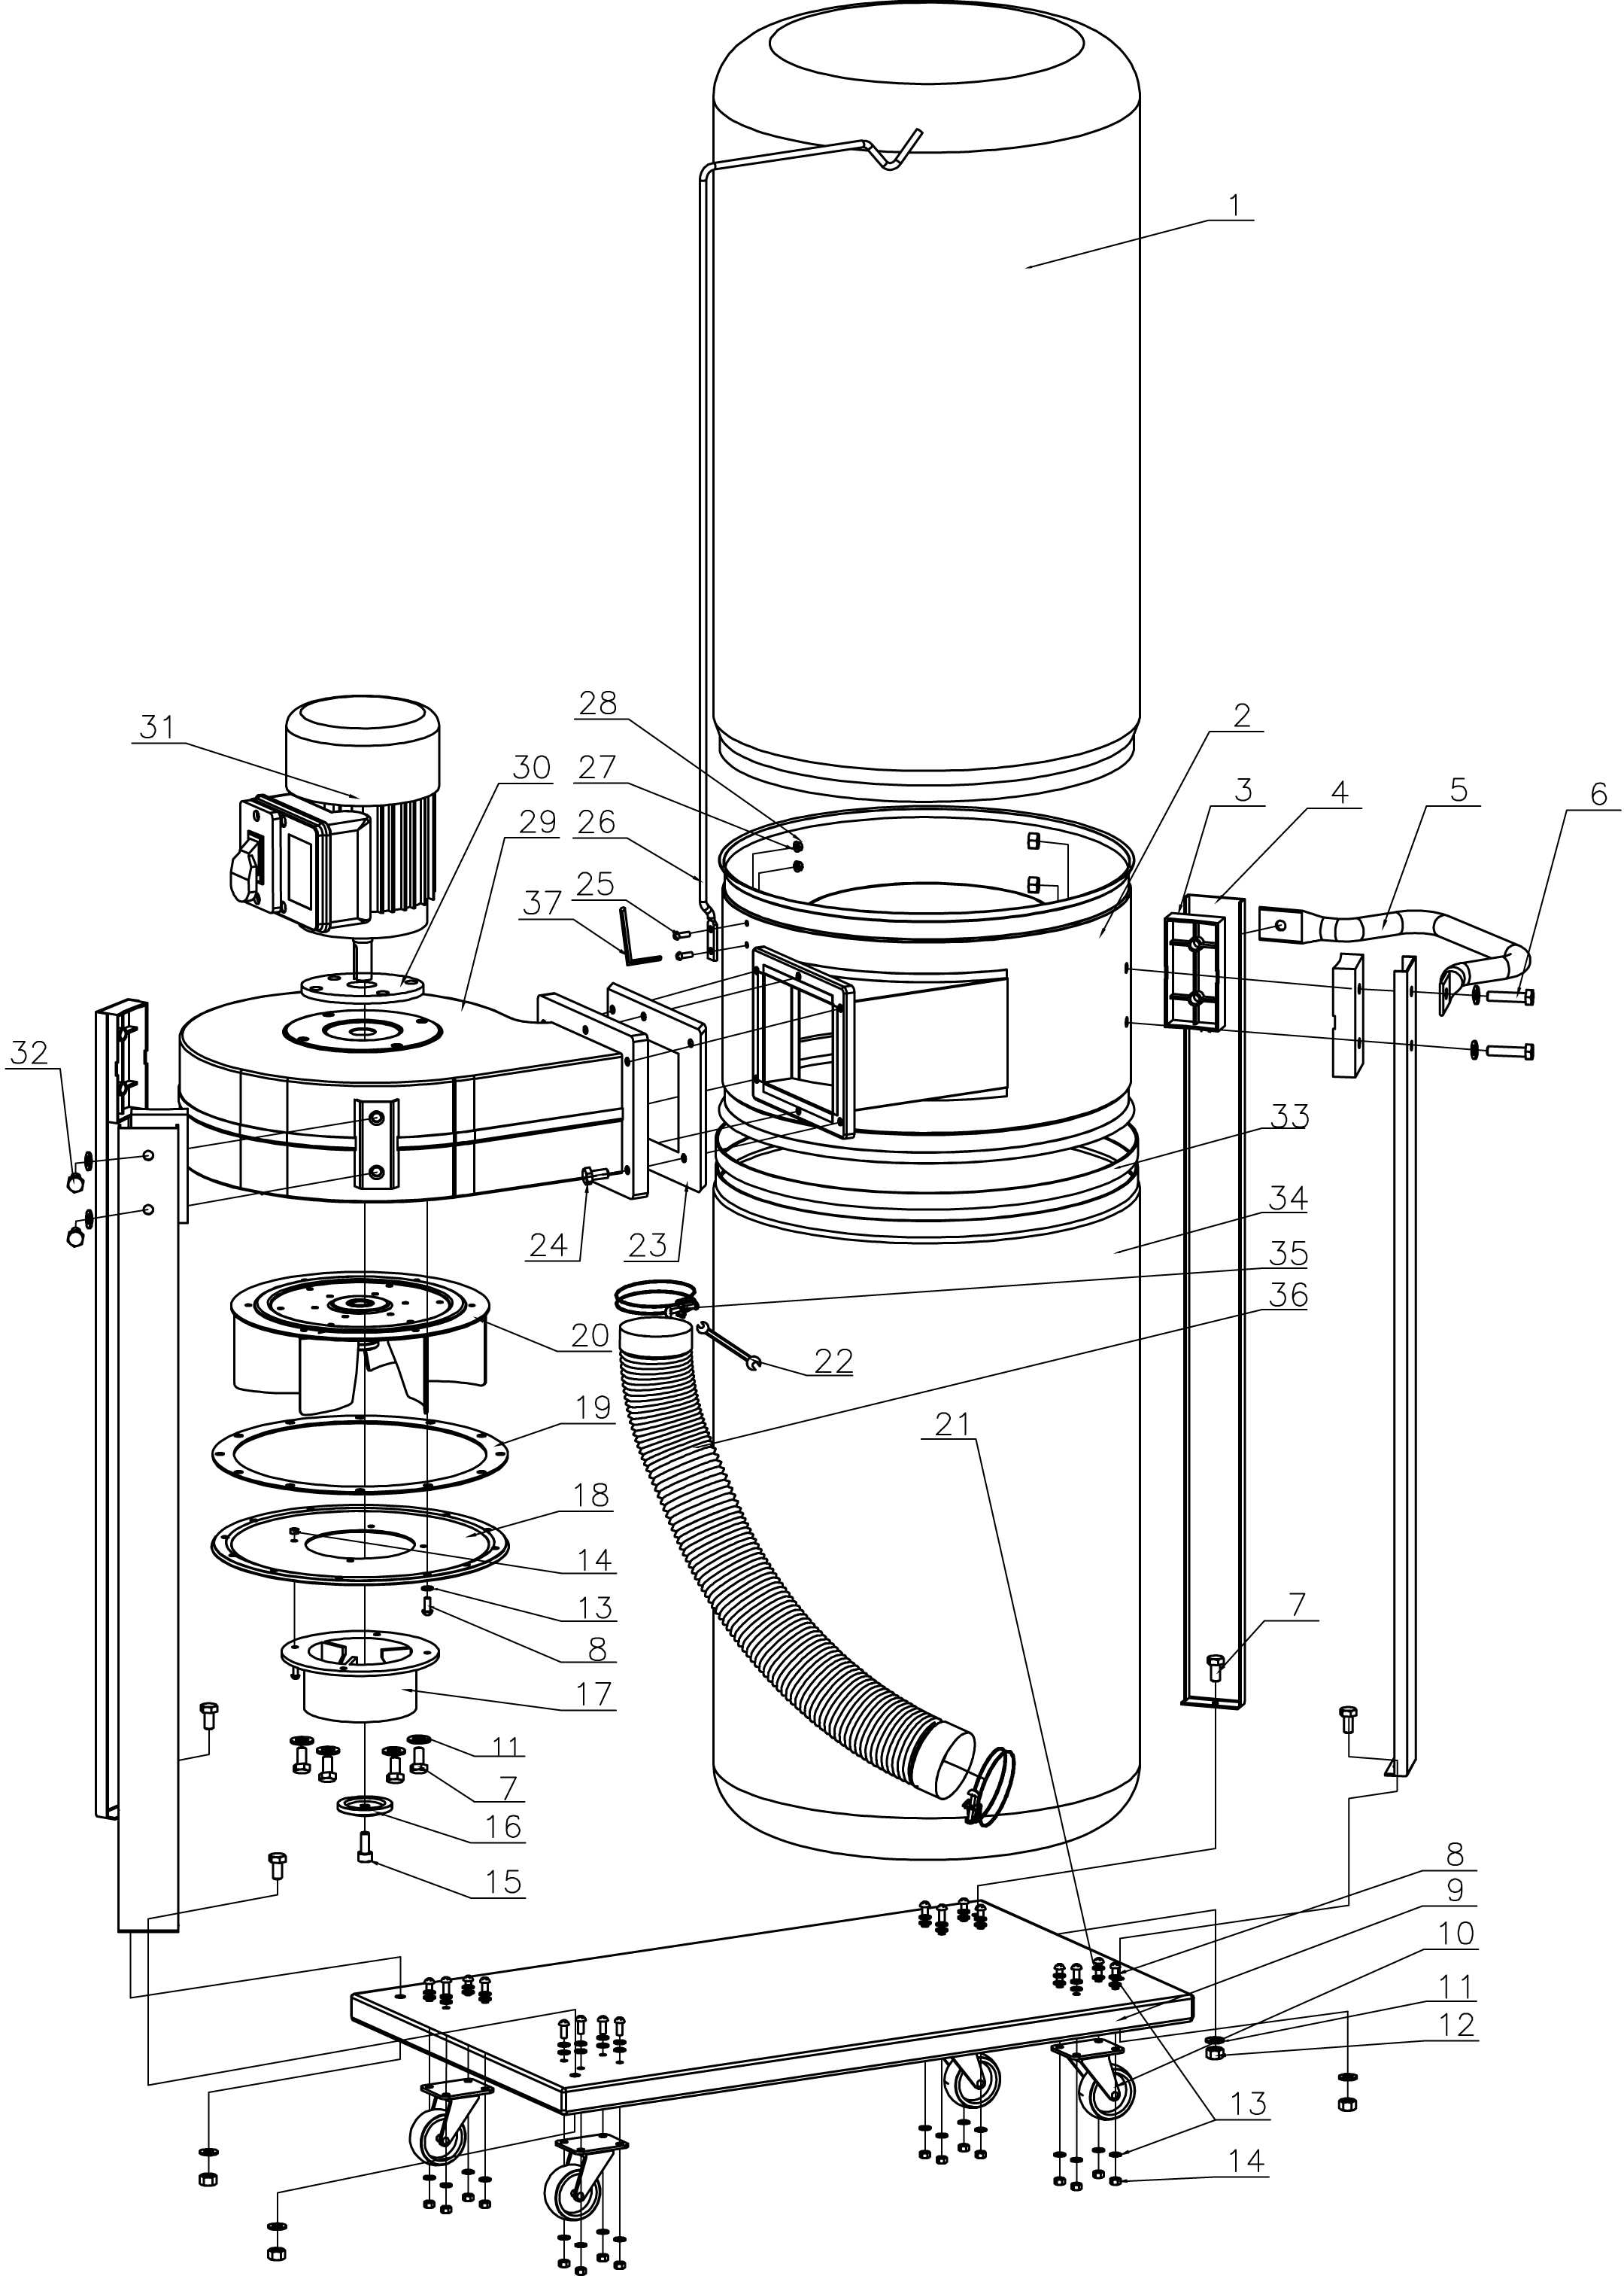

Parts List for DC-900 Dust Collector

Index | Part | Description | Size | Qty.
No. | No.
1 | DC900-001 | Cloth filter bag |  | 1
2 | DC900-002 | body |  | 1
3 | DC900-003 | Cushion |  | 4
4 | DC900-004 | leg |  | 4
5 | DC900-005 | handle |  | 1
6 | DC900-006 | Bolt | M8X35 | 8
7 | DC900-007 | Bolt | M8X12 | 8
8 | DC900-008 | Screw | M5X12 | 32
9 | DC900-009 | Base |  | 1
10 | DC900-010 | Wheel |  | 4
11 | DC900-011 | Washer | 8 | 20
12 | DC900-012 | Nut | M8 | 8
13 | DC900-013 | Washer | 5 | 52
14 | DC900-014 | Nut | M5 | 20
15 | DC900-015 | Screw | M6X16 | 1
16 | DC900-016 | Big Washer | 6 | 1
17 | DC900-017 | Intake port |  | 1
18 | DC900-018 | Plate |  | 1
19 | DC900-019 | Rubber cushion |  | 1
20 | DC900-020 | Fan |  | 1
21 | DC900-021 | Spring Washer | 5 | 16
22 | DC900-022 | Hex wrench | 8/10 | 1
23 | DC900-023 | Rubber cushion |  | 1
24 | DC900-024 | Bolt | M6X15 | 6
25 | DC900-025 | Screw | M4X12 | 2
26 | DC900-026 | Bag Hanger |  | 1
27 | DC900-027 | Washer | 4 | 2
28 | DC900-028 | Nut | M4 | 1
29 | DC900-029 | Fan housing |  | 1
30 | DC900-030 | Cushion |  | 1
31 | DC900-031 | Motor 230V, 50Hz complete assembly |  | 1
 | DC900-031RC | Running Capacitor (not shown) |  | 1
 | DC900-031-A | Switch box |  | 1
 | DC900-031-B | Switch plate |  | 1
 | DC900-031-C | Screw ST3.5X13 | ST3.5X13 | 2
 | DC900-031-D | On/Off Switch |  | 1
32 | DC900-032 | Bolt | M8X20 | 4
33 | DC900-033 | Bag clamp |  | 2
34 | DC900-034 | Collection bag |  | 3
35 | DC900-035 | Hose clamp |  | 2
36 | DC900-036 | Hose 100mm |  | 1
37 | DC900-037 | S3 Allen wrench |  | 1

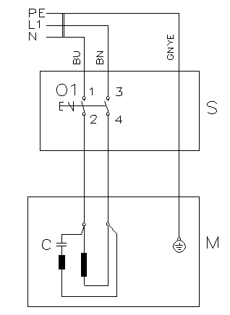
Wiring Diagram for DC-900 Dust Collector
10001051M…………………..…..~230V, 50Hz

 | colour of strands | Litzenfarben | couleur des cordons
BU | blue | blau | bleu
BN | brown | braun | brun
GNYE | green-yellow | grün-gelb | vert-jaune

 | meaning of symbol | Bedeutung der Zeichen | interprétation
M | motor | Motor | moteur
S | switch | Schalter | interrupteur
C | condenser | Kondensator | condensateur

